# Details of issues while editing

The group has the project downloaded and imported into NetBeans, however, we cannot make any changes to the project, which will be shown in the following pictures.  
  
1: The index file has already been modified as shown here.

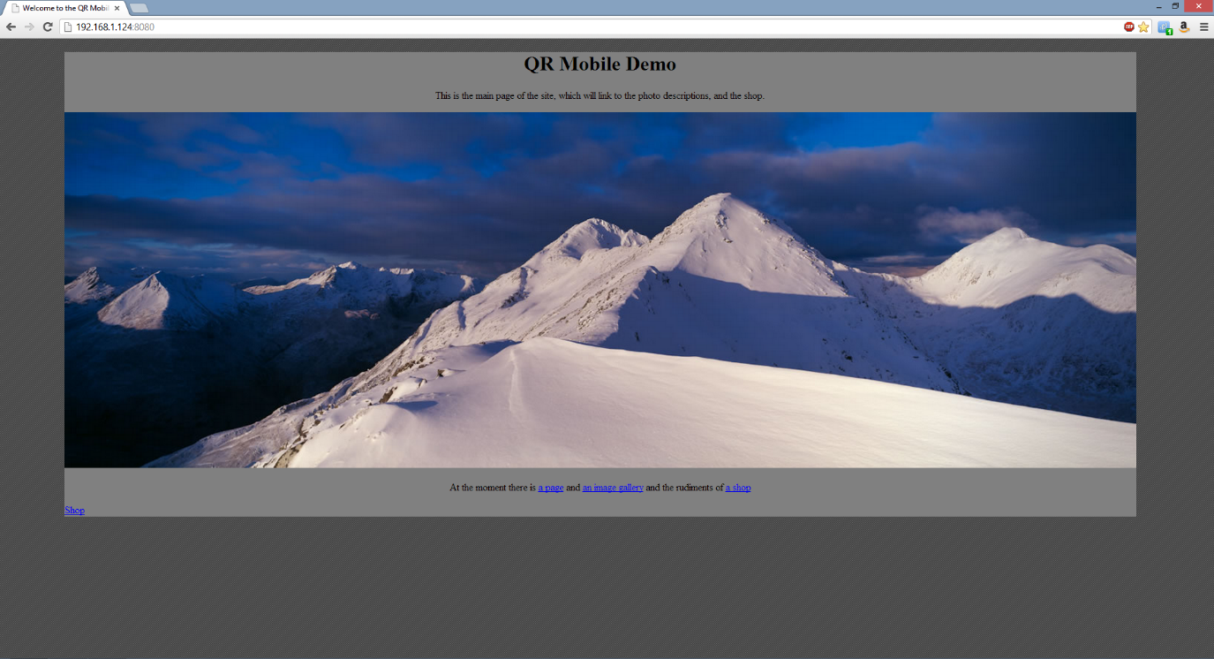

You can also see this at <http://jameschurchill.no-ip.org> as it is running on a live server.

2: We copy the source code (the edited code) from the server into the IDE source code view:

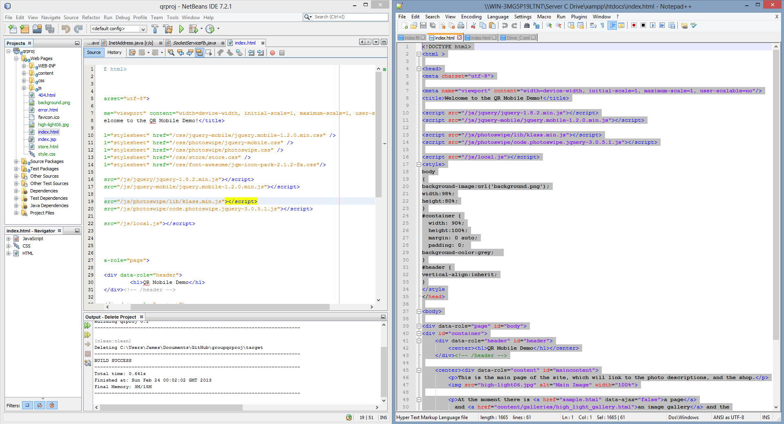

3: We copy all other necessary files over (background image, edited store html etc):

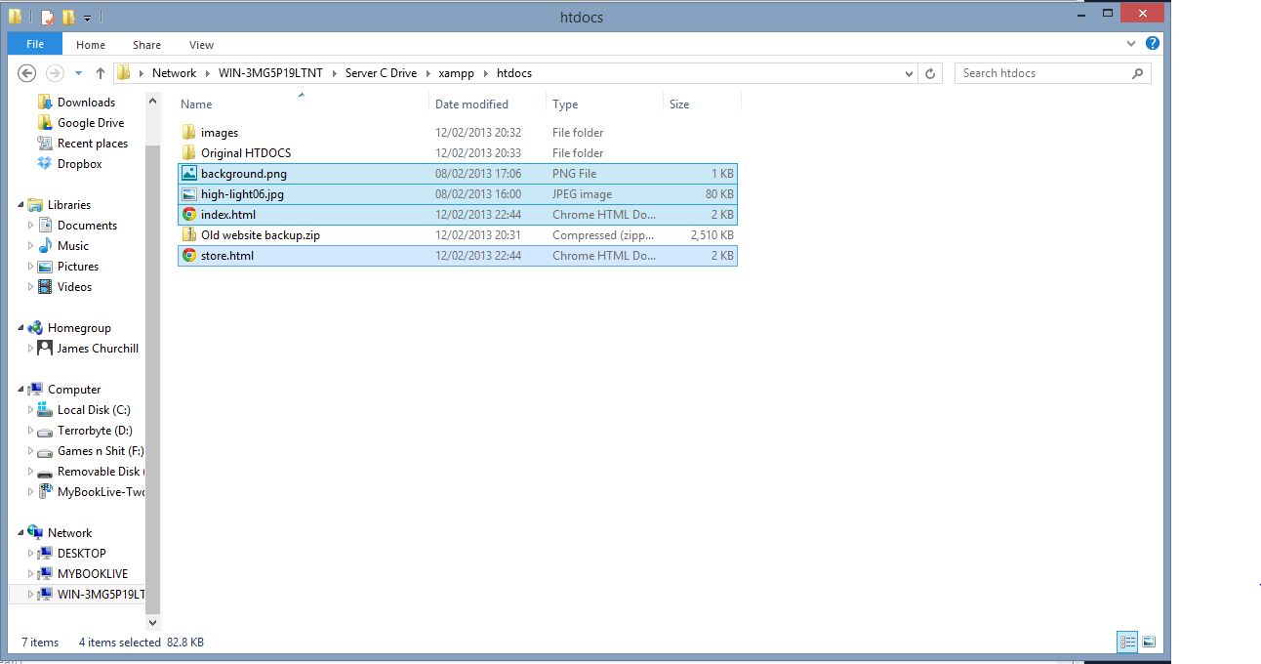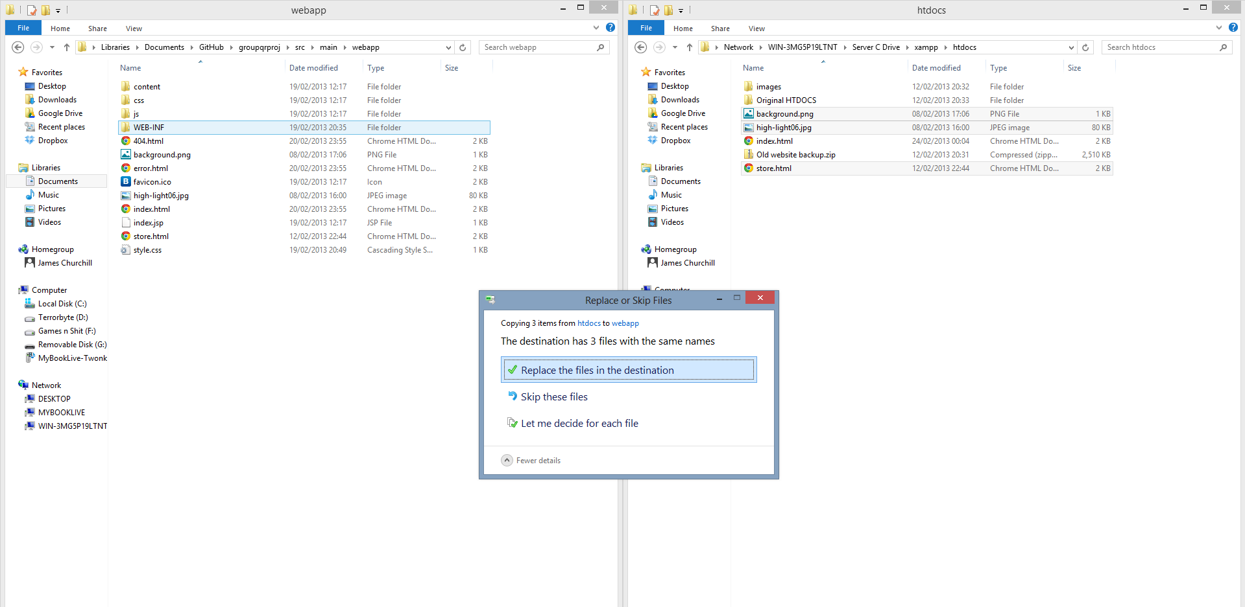

And they appear in the IDE window:

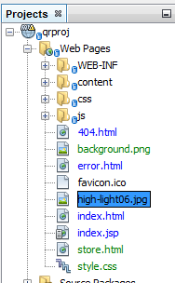

4: We then deploy the code to AppEngine, which runs as follows:

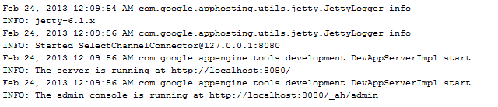

However, when we connect to localhost:8080/index.html, the original layout is still present:

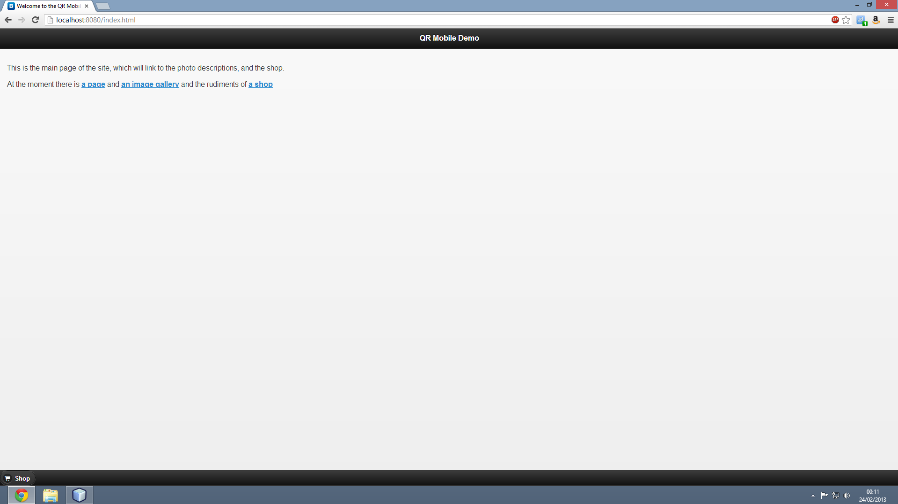

What are we doing wrong and how do we rectify this?